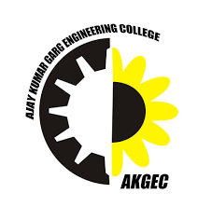 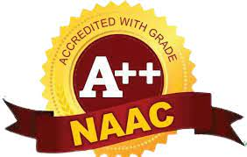

***International Conference***

***on***

***Relevance of Applied Sciences to Emerging Technology***

**ROASET-II 2025**

# 

**June 29-30, 2025**

 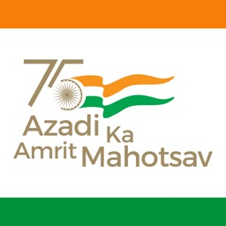

**Organized by**

Department of Applied Sciences & Humanities

Ajay Kumar Garg Engineering College, Ghaziabad (UP)

Affiliated to Dr. APJ Abdul Kalam Technical University, Lucknow, (UP), College Code-027

# Date and Venue of the Conference

The conference hosted by Department of Applied Sciences & Humanities, will be held offline at AKGEC, Ghaziabad, Uttar Pradesh, India from June 29-30, 2025. The conference will include regular sessions with poster/oral presentations, global and technical sessions and poster presentations organized in AKGEC.

# Conference Theme

The International Conference on Relevance of Applied Sciences to Emerging Technology (ROASET-II)aims to provide a common platform to researchers, academicians, industry partners and users for sharing relevance of applied sciences to emerging technology. The followings are the theme of the conference

* Mathematical Modelling and Simulation
* Approximation Theory
* Operation Research & Management Science
* Application of Fuzzy Logic & Probability
* High Speed Computational (HPC)
* Software Testing and Reliability
* Material Science
* Neural Network & Genetic Algorithm
* Reliability Theory
* Inventory Management
* Data Mining & Data Analysis
* Decision Science
* Nuclear Science
* Cryptography & Security System
* Numerical & Statistical Analysis
* Big data analytics
* Machine Learning
* Nano Science
* Photonics
* Waste Management & Energy Production
* Liquid Crystal
* Water Treatment & Reuse
* Astronomy and Astrophysics
* New challenges and their solutions in the field of Renewal energy sources
* Theoretical & Computational Physics.
* Material Science and Material characterization techniques
* Nuclear and High Energy Physics
* Nanotechnology and Nano-electronics
* Astronomy and Astrophysics
* Laser and Plasma Physics

**The conference will be organised in the following tracks**

**Track1:** Scope of Applied Mathematics in Emerging Technology  
**Track 2:** Relevance of Applied Chemistry in Engineering

**Track 3:** Recent trend and scope of Physics in Engineering & Technology

**Track 4:** Artificial Intelligence and Embedded Systems

**ABOUT**

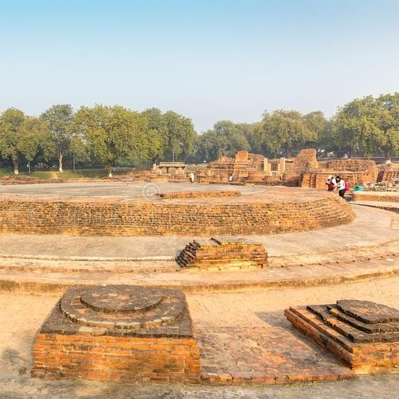

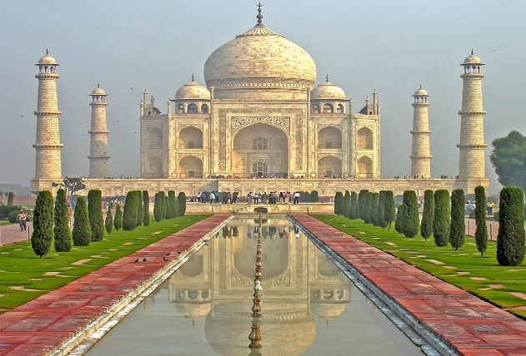

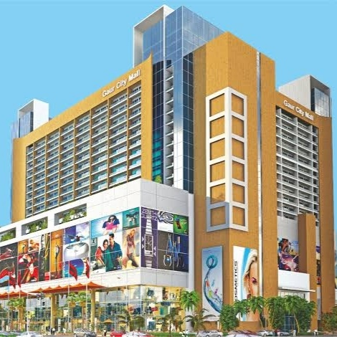

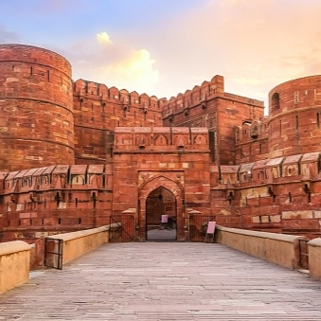

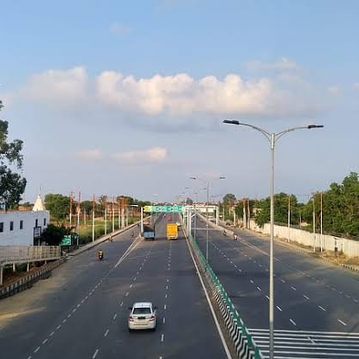

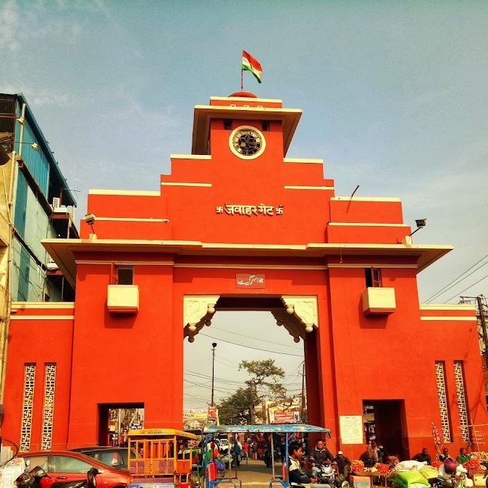

**AKGEC**

**SCALING THE ZENITH OF EXCELLENCE**

Driven by its commitment to provide quality technical education, Ajay Kumar Garg Engineering College has become the best Engineering institution in Uttar Pradesh. Ajay Kumar Garg Engineering College (AKGEC), Ghaziabad is affiliated to Dr. A.P.J. Abdul Kalam Technical University, Lucknow, and is approved by the All-India Council for Technical Education. The college was established in 1998 and offers B.Tech courses in nine disciplines of Engineering namely Computer Science and Engineering, Information Technology, Computer Science, Computer Science & Information Technology, Computer Science and Engineering (Artificial Intelligence & Machine Learning), Computer Science and Engineering (Data Science), Computer Science and Engineering (Hindi), Artificial Intelligence & Machine Learning, Electronics and Communication Engineering, Electrical and Electronics Engineering, Mechanical Engineering and Civil Engineering. B.Tech programs in Computer Science and Engineering, Information Technology, Electronics and Communication Engineering, Electrical and Electronics Engineering and Mechanical Engineering are accredited by NBA. At the post graduate level, the College offers M.Tech in Electronics & Communication Engineering, Computer Science, Electrical and Electronics Engineering and Mechanical Engineering and the Master of Computer Applications course.

The college strives for excellence and has been consistently maintaining excellent academic results and placements. The college has the distinction of being the first and only college in UP to receive the Academic Excellence Award for the Best Engineering College in UPTU (now AKTU) from H.E. the Governor of UP for two successive years. It is a matter of pride for the College to maintain a superlative overall academic performance over the years with a large number of students appearing in the University Merit List every year. The College has the honor of being awarded the Chancellor’s Award for highest marks in all B.Tech courses for five consecutive years in 2015-16, 2016-17, 2017-18, 2018-19 and 2019-20 since its inception in 2016.

The College has also set up the first Centre of Competence in Automation Technologies in North India in collaboration with BOSCH Rexroth AG, Germany. The centre aims to train young engineering graduates of all disciplines to meet industry expectations and foster research in the multidisciplinary field of automation technologies. This centre has six laboratories equipped with state-of-the-art equipment to teach and train students and professionals in Industrial Hydraulics, Pneumatics, Sensorics, Drives & Control, CNC, PLCs and Mechatronics at par with international standards.

The PLM Centre of Excellence set up in association with SIEMENS aims to develop engineering professionals equipped with next generation technologies. The centre provides education to the next generation of designers/engineers on software including SOLIDEDGE, NX and CAD/CAM/CAE for digital product engineering, Team Centre for product life cycle management and Technomatix for digital manufacturing. It addresses diverse industry segments like automotive, industrial machinery, industrial automation, aerospace and shipbuilding.

To promote Industry oriented teaching learning, AKGEC has setup Centre for Integrated Automation in association with Automation Industry Association (AIA). This initiative of AIA is intended to share global quality learning processes from its vast pool of member companies with chosen Engineering Colleges of our country. The College has also set up U.P.’s first Industrial Pneumatic Knowledge Centre (IPKC) in collaboration with Janatics, Coimbatore. The initiative of setting up IPKC reflects Janatics’ endeavour to contribute towards producing skilled workforce in Pneumatics which will help manufacturing sector to adopt to changes related to automation in substantive way.

Ajay Kumar Garg Engineering College, jointly with Fronius International GmbH has set up India’s first Advanced Welding Technology and Research Centre (AWTRC) in the state of Uttar Pradesh. AWTRC has been established with an aim of developing outstanding infrastructure for becoming a globally recognized source of a competitive workforce and cost-effective, superior-performing welding technologies by conducting training, research and development in the field of welding science, engineering and automation technology. AKGEC, jointly with SIEMENS, has set up Advance Manufacturing Centre for SMEs and educational institutions at Ghaziabad. The AKGEC- Siemens Training Centre is setup to produce highly skilled technical manpower in the field of Advance Manufacturing. The trained manpower will help Indian Manufacturing Industry to adopt latest technologies to improve quality and work conditions with high productivity.

Fab Lab is an initiative of Prof. Neil Gershenfeld from MIT, USA which is typically equipped with an array of flexible computer-controlled tools that cover several different length scales and various materials, with the aim to make “almost anything". AKGEC has established Fab Lab in response to the need arising from students requiring a dedicated space and appropriate equipment to develop their projects. Since then, it evolved from being just a product development Centre to a facility focused on promoting innovation, imparting much-needed skills for innovators and help developing competency across different disciplines including mechanical, electronics and embedded development areas.

The efforts of the college to bridge the gap between academic curriculum and industry requirements through these centers of Excellence & Competence have been recognized and the college is the recipient of the CMAI Best Industry Interface award from the Hon’ble Minister of Science & Technology, UP Govt.

In addition, the College has established the Big Data Centre of Excellence, Software Development Centre and Open-Source Software Research & Development lab

As a result of these initiatives, the college has been having excellent campus placements. During the current academic year, over 800 students have been placed in PSUs and reputed organizations like Infosys, HCL Technologies, L&T, L&T Infotech, Hyundai, Wipro Technologies, Jakson Engineers Ltd., NTPC, IBM, Indian Air Force and the Indian Army. The main distinguishing features of the college have been uniform transparent policies and systems as well as uncompromising honesty in every facet of its activities. The college believes in setting audacious goals and infusing fresh ideas to achieve them.

**AKGEC Conference**

The objective of the conference is to exchange new knowledge and recent development in all aspects of computational techniques, mathematical modelling, energy systems, and many more and its aim is to provide a forum for engineers, researchers, and specialists from academia, research centres and industry worldwide to discuss and present the scope of applied sciences in emerging technology and computational intelligence for sustainable Technologies

The International Conference on Relevance of Applied Sciences to Emerging Technology (ROASET-II) is organized by the Department of Applied Sciences & Humanities Ajay Kumar Garg Engineering College, Ghaziabad (UP) affiliated to Dr. APJ Abdul Kalam Technical University, Lucknow, (UP) India.

The conference will provide an opportunity for researchers, academicians and students to share their knowledge and discuss the latest developments in their field of expertise. This conference provides the platform for the young researchers to interact with eminent scientists and researchers across the globe. In this conference an equal opportunity is provided to all the participants to share their ideas in the area of interdisciplinary mathematics, statistics, computational intelligence and renewable energy.

**About the Department**

To equip the students with sound concepts of Applied Sciences the college has a separate department. AKGEC covers the entire spectrum of education that gives a unique all-round perspective of holistic education process, not just in terms of preparing competent professionals for the country, but also provides a firm grounding in human values to produce well rounded and conscientious citizens and leaders.

The department offers core courses in Humanities, Applied Mathematics, Applied Physics and Applied Chemistry.

The department consisting with the latest developments in terms of curriculum, well qualified faculty and state of the art laboratories. The department laboratories are well equipped with the latest equipment, catering the needs of curriculum and bridging the industry –academia gap. The department is committed to provide the best teaching – learning and R & D environment through its learned faculty members, year-round conduction of seminars, guest lectures, industry interactions, soft skills and technical trainings, co-curricular & extracurricular activities.

**About Ghaziabad**

Ghaziabad is a city in the Indian state of Uttar Pradesh and a part of the NCR. It is the administrative headquarters of Ghaziabad district and is the largest city in western Uttar Pradesh, with a population of 1,729,000. Ghaziabad Municipal Corporation is divided into 5 zones - City Zone, Kavi Nagar Zone, Vijay Nagar Zone, Mohan Nagar Zone and Vasundhara Zone. The Municipal Corporation comprises 100 wards. Well connected by roads and railways, it is a major rail junction for North India. It is sometimes referred to as the "Saya of Uttar Pradesh" because it is close to New Delhi, on the main route into Uttar Pradesh. Recent construction works have led to the city being described by a City Mayors Foundation survey as the second fastest-growing in the world. Situated in the Upper Gangetic Plains, the city has two major divisions separated by the Hindon River, namely Trans-Hindon on the west and Cis-Hindon on the east.

The city of Ghaziabad was founded in 1740 A.D. by Ghazi-ud-Din, who served as a wazir in the court of Mughal emperor Muhammad Shah, and named it as "Ghaziuddinnagar" after his own name. The name "Ghaziuddinnagar" was shortened to its present form, i.e. "Ghaziabad" with the opening of the Railways in 1864. During the Mughal period, Ghaziabad and especially the banks of the Hindon in Ghaziabad, remained a picnic spot for the Mughal royal family.  
  
Establishment of the Scientific Society here, during the same period is considered as a milestone of the educational movement launched by Syed Ahmad Khan. The Scinde, Punjab & Delhi Railway, connecting Delhi and Lahore, up till Ambala through Ghaziabad was opened in the same year. With the completion of the Amritsar-Saharanpur-Ghaziabad line of the Sind, Punjab and Delhi Railway in 1870, Delhi was connected to Multan through Ghaziabad, and Ghaziabad became the junction of the East Indian Railway and Sind, Punjab and Delhi Railway.

# Uttar Pradesh

Uttar Pradesh ('Northern Province') is a state in northern India. With over 200 million inhabitants, it is the most populated state in India as well as the most populous country subdivision in the world. It was created on 1 April 1937 as the United Provinces of Agra and Oudh during British rule, and was renamed Uttar Pradesh in 1950, giving it the acronym UP. The state is divided into 18 divisions and 75 districts, with the state capital being Lucknow, and Allahabad serving as the judicial capital. On 9 November 2000, a new state, Uttaranchal (now Uttarakhand), was carved from the state's Himalayan hill region. The two major rivers of the state, the Ganges and Yamuna, join at Triveni Sangam in Prayagraj and flow further east as Ganges. Other prominent rivers are Gomti and Saryu. The forest cover in the state is 6.1% of the state's geographical area.

The cultivable area is 82% of total geographical area and net area sown is 68.5% of cultivable area.The state is bordered by Rajasthan to the west, Haryana, Himachal Pradesh and Delhi to the northwest, Uttarakhand and an international border with Nepal to the north, Bihar to the east, Madhya Pradesh to the south, and touches the states of Jharkhand and Chhattisgarh to the southeast. It covers 240,928 km2 (93,023 sq mi), equal to 7.3% of the total area of India, and is the fourth-largest Indian state by area. Though long known for sugar production, the state's economy is now dominated by the services industry. The service sector comprises travel and tourism, hotel industry, real estate, insurance and financial consultancies. The economy of Uttar Pradesh is the second-largest state economy in India with ₹21.73 lakh crore (US$290 billion) in gross domestic product and a per capita GSDP of ₹95,000 (US$1,300). President's rule has been imposed in Uttar Pradesh ten times since 1968, for different reasons and for a total of 1,700 days. The state has currently two international airports, Chaudhary Charan Singh Airport (Lucknow) and Lal Bahadur Shastri Airport (Varanasi).

Uttar Pradesh ranks first in domestic tourist arrivals among all states of India with more than 71 million, owing to its rich and varied topography, vibrant culture, festivals, monuments, ancient places of worship, and viharas. Uttar Pradesh is also home to three World Heritage Sites: the Taj Mahal, Agra Fort, and the nearby Fatehpur Sikri. Uttar Pradesh is a favoured tourist destination in India due to the location of Taj Mahal, nearly 69 lakhs (6.9 million) people visited the Taj Mahal in 2018–19, up 6% from the previous year when the number stood at 64 lakhs (6.4 million). The monument earned almost ₹78 crore (US$10 million) in ticket sales in 2018–19. The state's tourism industry is a major contributor to the state's economy, growing at the rate of 21.60%.

# Committee

|  |  |
| --- | --- |
| **Chair Person/ Chief Patron** | **Patron** |
| Dr. R.K. Agarwal | Dr. Hemant Ahuja |
| Director General, AKGEC | Director, AKGEC |

|  |  |
| --- | --- |
| **General Chair** | **Conference Chair** |
| Dr. B.K. Panigrahi | Prof (Col.) S. L. Kapoor |
| Professor, IIT Delhi | HOD AS & Hum., AKGEC |

|  |  |  |
| --- | --- | --- |
| **Organizing Chair** | | |
| Dr. BB Verma | Dr. Anand Tyagi | Dr. Sanjay Sharma |
| Professor (ASH), AKGEC | Assistant Professor (ASH), AKGEC | Assistant Professor (ASH), AKGEC |

|  |  |
| --- | --- |
| **Finance Chair** | |
| Mr. Vikas Roshan | Mr. Vishal Gupta |
| Assistant Professor (EN), AKGEC | Assistant Professor (ASH), AKGEC |

|  |  |
| --- | --- |
| **Publicity Chair** | |
| Dr. Akash | Dr. Niti Maheshwari |
| Assistant Professor (ASH), AKGEC | Assistant Professor (ASH), AKGEC |
| Dr. Tarunjeet Singh | Dr. Arvind Sharma |
| Assistant Professor (ASH), AKGEC | Assistant Professor (ASH), AKGEC |

|  |  |
| --- | --- |
| **Publication Chair** | |
| Dr. Kanika | Dr. Ekta Pandey |
| Assistant Professor (ASH), AKGEC | Assistant Professor (ASH), AKGEC |

|  |  |  |
| --- | --- | --- |
| **Screening Committee** | | |
| Dr. Rahul Kumar Pandey | Dr. Virender Kumar | Dr. Vimlesh Mishra |
| Assistant Professor (ASH), AKGEC | Assistant Professor (ASH), AKGEC | Assistant Professor (ASH), AKGEC |
| Dr. Nitin Kumar Sharma | Dr. Meenakshi Shrivastava |  |
| Assistant Professor (ASH), AKGEC | Assistant Professor (ASH), AKGEC |  |

**Honorary Advisory Committee**

|  |  |  |
| --- | --- | --- |
| **S No.** | **Name and Designation** | **Affiliation** |
| 1 | Dr. Ambrish Chandra | Professor, Ecole de Technologies Superieure, University of Quebec, Montreal, Quebec. |
| 2 | Dr. Bhim Singh | Professor, Indian Institute of Technology Delhi |
| 3 | Dr. Frede Blaabjerg | Professor, AAU Energy |
| 4 | Dr. G Bhuvaneshwari | Professor, Indian Institute of Technology Delhi |
| 5 | Dr. Garabed Boghossian | Lecturer, Haigazian University, Lebanon |
| 6 | Dr. Harish Sharma Krishnamoorthy | Assistant Professor, University of Houston |
| 7 | Dr. Hatem Hatef Abdulkadim Altae | Professor, Cihan University, Iraq |
| 8 | Dr. Herbert H.C Lu | Professor, University of Western Australia |
| 9 | Dr. Kaushik Rajashekara | Distinguished Professor of Engineering, University of Houston |
| 10 | Dr. M.A. Rahman | Professor, Memorial University of Newfoundland, Engineering and Applied Science. |
| 11 | Dr. Mohan Lal Kolhe | Professor, Smart and Renewable Energy, Faculty of Engineering and Science, University of Agder, Norway |
| 12 | Dr. Muhammad H Rashid | Professor, Florida Polytechnic University |
| 13 | Dr. Ned Mohan | Regents Professor, University of Minnesota, United States |
| 14 | Dr. O P. Malik | Professor Emeritus, The University of Calgary, Department of Electrical and Computer Engineering |
| 15 | Dr. Parimita Mohanty | Programme Management Officer, UNEP, Bangkok, TERI |
| 16 | Dr. Pramod Agarwal | Professor, Indian Institute of Technology Roorkee |
| 17 | Dr. Prasad Enjeti | Professor, Electrical & Computer Engineering Texas A&M University |
| 18 | Dr. R. Balasubramanian | Professor, Indian Institute of Technology Delhi |
| 19 | Dr. Rajiv K. Verma | Professor, Electrical and Computer Engg., The University of Western Ontario, London, ON, Canada |
| 20 | Dr. Ramkrishan Maheshwari | Lektor, Centre for Industrial Electronics, University of Southern Denmark. |
| 21 | Dr. Seyed M.K. Sadr | Postdoctoral Research Fellow, University of Exeter, United Kingdom |
| 22 | Dr. Shady H.E. Abdul Aleem | Associate Professor, High Valley Institute for Engineering & Technology, Egypt |
| 23 | Dr. Shailaditya Verma | Lecturer, Higher Colleges of Technology, Fujairah Women’s College |
| 24 | Dr. Siva Kumar K. | Associate Professor, IIT Hyderabad, Kandi |
| 25 | Dr. Sudipta Ghosh | Khaufa Univ. of Sciences and Tech. Abu Dhabi, United Arab Emirates |
| 26 | Dr. Tzung-Pei Hong | Distinguished Professor, National University of Kaohsiung, Taiwan |
| 27 | Dr. Urmil Parikh | Global, Program Manager, Hitachi Energy India Limited |
| 28 | Dr. Valentina E.Balas | Professor, Aurel Vlaicu University of Arad, Romania |
| 29 | Dr. Wael R. Abdulmajeed | Postgraduate Studies Coordinator, University of Baghdad |
| 30 | Dr. Yu-Chen Hu | Distinguished Professor, Providence University, Shalu, Taiwan |
| 31 | Dr. Sanjeet Dwivedi | Danfoss Power Electronics A/S, Drive Intelligence Group Gråsten, Denmark |
| 32 | Dr. Talochan S. Sidhu | Professor & Chair, Department of Electrical and Computer Engineering, The University of Western Ontario, London, Ontario, Canada |
| 33 | Mr. Aashutosh Sharma | CEO, Voltrans Energy, Noida |
| 34 | Mr. Amit Agarwal | Dy. Managing Director Ghaziabad Precision Products Pvt. Ltd., Ghaziabad |
| 35 | Mr. Ankur Jain | Analytics Operations Quality, GE Power |
| 36 | Mr. Kshitiz Kulshrestha | GM (SPM), Reliance Jio, Mumbai |
| 37 | Mr. Navneet Kumar | DGM(SPM), Reliance Jio, Mumbai |
| 38 | Mr. R.R. Tanwar | Council Member, IEI, Electrical Division |
| 39 | Mr. Rajesh Bhalla | Manager, Larsen & Turbo Limited |
| 40 | Mr. Subramanyam Pulipaka | CEO, National Solar Federation of India |
| 41 | Mr. Vikas Marwah | Sr. Aditional GM, Satluj Jal Vidyut Nigam, Himachal Pradesh |
| 42 | Mr. Vikas Munjal | Technical Program Manager, Google, California, USA |
| 43 | Mr. Vineet Saini | Scientist, Department of Science and Technology, Delhi |
| 44 | Mr. Yogesh Ratra | Sr. Control Systems Design Engineer, Fluor Corporation, Canada |
| **Honorary Technical Committee** | |  |
| **S No.** | **Name and Designation** | **Affiliation** |
| 1 | Dr. A. N. Tiwari | Professor, Electrical Engineering Department, MMMUT, Gorakhpur |
| 2 | Dr. A.K. Tandon | Former professor DTU, Delhi |
| 3 | Dr. Ajay Shekhar Pandey | Professor, EE, KNIT Sultanpur |
| 4 | Dr. AkshayGirdhar | Professor, Electrical Engineering Department, GNDEC, Ludhiana |
| 5 | Dr. Ambarisha Mishra | Assistant Professor, Electrical Engineering Department, NIT Patna |
| 6 | Dr. Amit Jain | Associate Professor, Electrical Engineering Department, IIT Delhi |
| 7 | Dr. Anish Gupta | Assistant Director, Chandigarh University |
| 8 | Dr. Anupma Marwaha | Professor, Electrical and Electronics Engineering, SLIET, Longowal |
| 9 | Dr. Anuradha Tomar | Associate Professor, NSUT, Delhi |
| 10 | Dr. Apurva Anand | BBDIT University, Lucknow |

**Organizing Committee**

|  |  |
| --- | --- |
| Dr. BB Verma | Professor |
| Dr. Shiwani Singhal | Associate Professor |
| Dr. M.K. Goyal | Assistant Professor |
| Dr. Bandana Sharma | Assistant Professor |
| Dr. Nitya Sharma | Assistant Professor |
| Dr. Monika Sharma | Assistant Professor |

# Call for Paper

Original research papers on theoretical & experimental works and case studies on the mentioned themes and related topics will be invited from the prospective authors. The paper submitted should not have been published or accepted for publication in journals/conferences. The prospective authors will upload the full paper as per the Conference format and in MS word (doc or docs) formats. Prospective authors will be invited to submit their formatted full papers through Online Conference management system, most likely, easy chair.

The focus area and tracks of the conference would be:

**Track 1:** Scope of Applied Mathematics in Emerging Technology

**Track 2:** Relevance of Applied Chemistry in Engineering

**Track 3:** Recent trend and scope of Physics in Engineering & Technology

**Track 4:** Artificial Intelligence and Embedded Systems

### **Paper format (A Brief Idea)**

* The paper size is European A4.
* Margins are 4cm (top), 2.5cm (left and right) and 2.7cm (bottom).
* There are no page numbers, headers, or footers within the paper.
* Text is single-spaced, not double-spaced.
* All fonts are embedded.
* All pages are portrait (landscape pages should be rotated).
* The abstract text should be indented 25mm from the left margin and there should be 10mm space after the abstract before you begin the main text of your article.

### **Paper content**

* The paper includes the author's name(s) and affiliation(s) (full address including country).
* All articles must contain an abstract.
* All figures and tables should be numbered in numerical order. Please ensure that figure/table numbers are not duplicated or missed.
* Figures are legible and placed within the text, not collected at the end of the document.
* If section headings are numbered, ensure that they are numbered numerically, and no numbers are duplicated or missing.
* Displayed equations should follow a naming convention in numerical order, i.e. (1), (2), (3) etc or by section, i.e. (1.1), (1.2) etc.
* Reference lists are checked for accuracy. References can only be linked via CrossRef if they are correct and complete. Check templates and guidance page for reference.
* Ensure that references are numbered numerically, every reference has its own number and no numbers are duplicated or missing.
* Ensure that all references are cited in the text and that all citations have a corresponding reference.
* Finally, ensure that the paper is thoroughly proofread to check the standard of English and wording is clear and concise.

### **Conversion to PDF**

* The PDF file is editable and not password-protected.
* The PDF is free of formatting errors (e.g. corrupt equations, missing or poor-resolution figures) since conversion from Word to PDF can introduce formatting errors.
* There are no blank pages.

### **Review and Publication**

All the submitted papers will undergo a review process by the International Review Committee of AKGEC 2025. All the accepted, registered and presented manuscripts shall be published in the proceedings of **SCOPUS indexed journals.**

**The papers in the correct format will only be considered for review and publication.**

**It is requested to circulate this call for papers to your research circle and academic community who may be benefited.**

### **Mode of presentation**

The conference will be organized in offline mode. The Authors may request, in advance, the organizers for presenting the papers in offline mode only.

# Track Details

**Track 1:** **Scope of Applied Mathematics in Emerging Technology**

**Applied Mathematics:** Continuum and Fluid Mechanics, Control Theory, Differential Equations, Dynamical Systems, Quantum Theory, Relativity and Cosmology, Scientific Computing. Applied Reticular Theory, Big data, Biomathematics, Differential Equations, Models, Group Theory and Applied Lie Algebra, Logistics and Transportation, Models for Handling uncertainty

**Operations Research and Management:** Supply cain management, Inventory Management, Hub and Spoke Systems' Design, Cooperation in Pharm. Industry, Lot-Sizing Algorithms, Design of Electricity Markets, Layout Optimization, Business Process Analysis, Decomposition.

**Reliability Theory and Flod Dynamics:** The continuity equation, The momentum principle, Energy equation, Hardware Reliability, Data Recovery, Data Reliability Assurance, Data Reliability Model, Generalizability, Hazard Function, Random Variable, discrete-time,

**Track 2:** Sustainable approach of Applied Chemistry in the field of Science and Technology

1. Nanomaterials and applications

2. Green Chemistry

3. Industrial chemicals and Environment

4. Synthesis of Metal Complexes via Green approach

5. Climate change and Resilience

6. Biopolymers and Bioactive Gels

7. Recovery of metals via Phytoremediation, Biosorption etc.

8. Role of Artificial Intelligence in Environment Chemistry

9. Metallurgy and metal working

**Track 3:** Recent trend and scope of Physics in Engineering & Technology

1. Astronomy and Astrophysics

2. New challenges and their solutions in the field of Renewal energy sources

3. [Theoretical and Computational Physics](https://cdsweb.cern.ch/record/2143813)

4. Material Science and Material characterization techniques

5. Nuclear and High Energy Physics

6. Nanotechnology and Nano-electronics

7. Astronomy and Astrophysics

8. Laser and Plasma Physics

**Track 4:** Artificial Intelligence and Embedded Systems

* 1. Business Analytics
  2. Data Analysis
  3. Decision Systems, Geoinformatics
  4. Algorithms
  5. Combinatorial Mathematics
  6. Complex Analysis
  7. Control Theory
  8. Ambient Computing & Cloud Computing
  9. Computer Science Logic
  10. Computer Vision
  11. Computer-Aided Verification
  12. Internet of things technologies
  13. Machine learning
  14. Artificial intelligence for big data analysis of digital environments.

# Plans for Publication of Proceedings

• All the presented papers will be indexed in a Scopus Journal.  
• Best paper award will be given for each theme.

# Important Timelines

|  |  |
| --- | --- |
| Invitation for Papers | 15th March 2025 |
| Submission of Paper | 1st April 2025 |
| Notification to Authors | 10st April 2025 |
| Final Version of Accepted Submissions | 1st May 2025 |
| Registration and Camera-Ready Copy Submission | 20th May 2025 |
| Conference Date | 29-30th June 2025 |

**Registration Fees**

|  |  |  |
| --- | --- | --- |
| **Early Birds** | **Indian Author** | **Foreign Author** |
| Participants from Industries | Rs. 3000 | $ 150 |
| Academia | Rs. 2500 | $ 100 |
| Research Scholars and students | Rs. 1500 | $ 50 |
| Poster Presentation | Rs. 1000 | $ 40 |
| Co-authors & Attendees | Rs. 1000 | $ 150 |

10% fee concession to IEI and IEEE Members. The fee entitles the delegates to participate in technical sessions, conference kit, copy of the proceedings, lunch and refreshments on each day of conference. Registration and rest proceedings will be done through the conference website: [roaset2025@akgec.ac.in](mailto:roaset2025@akgec.ac.in)

**Fee Submission Details**

|  |  |
| --- | --- |
| **Details of IMPS/UPI/RTGS/NEFT:** | |
| Name of Beneficiary | Ajay Kumar Garg Engineering College |
| Name of the Bank | Kotak Mahindra Bank Ltd. |
| Branch Address | 30 & 31 Navyug Market, P.B. No. 75, Ghaziabad-201001 (U.P.) - INDIA |
| Branch Code | 5295 |
| Bank Account No. | 5.0801E+11 |
| Type of Bank Account | Savings Bank Accounts |
| RTGS/NEFT/IFSC Code | KKBK0005295 |
| Contact No. | 0120-2790969 |

# Accommodation

Participants will make their own arrangements for travel, boarding, lodging etc. However, limited accommodation facility may be provided to the participants in hostels and guest rooms of the institute on special request. For lady participants’ accommodation shall be arranged in the Girls hostels of the institute, on request. For guests, the accommodation shall be arranged by our Institute.